IGNOU BCA 1st SEM COMPUTER BASIC AND PC SOFTWARE

BLOCK-1, UNIT-1

1. **Discuss about Von Neumann architecture with proper diagram.**

The Von Neumann architecture, proposed by mathematician and physicist John von Neumann in the 1940s, has profoundly shaped the field of computing.

Its fundamental design concept—a stored-program computer—became the foundation for modern digital computers. This architecture simplified computing processes and allowed computers to become versatile and programmable. Let's break down the architecture itself, its core principles, and its lasting impact on computing**.**

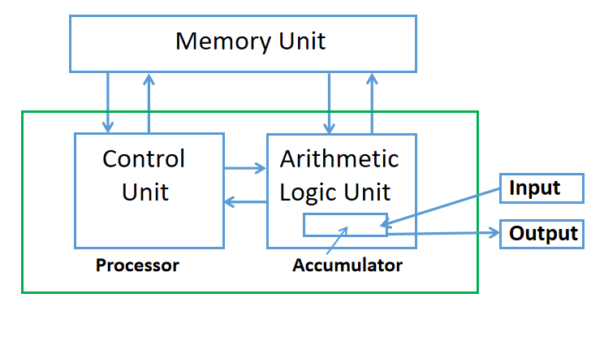

The Von Neumann architecture describes a computer design model that includes the following key components:

**Central Processing Unit (CPU):** This consists of the Arithmetic Logic Unit (ALU), which performs computations, and the Control Unit (CU), which directs data flow within the system.

**Memory:** A storage area that holds both data and program instructions. In Von Neumann architecture, the memory is unified—meaning it holds both instructions and data.

**Input/Output (I/O):** Interfaces that allow data to enter and leave the computer (e.g., keyboards, screens, storage devices).

**Bus System:** Communication pathways that transfer data and instructions between components.

The key principle of the Von Neumann model is that both program instructions and data are stored in the same memory. This design enables the system to read and execute instructions sequentially, which is crucial for general-purpose computing.

**Core Principles and Features of Von Neumann Architecture**

**Stored-Program Concept:** Programs and data are stored in the same memory, which allows the machine to modify its operations based on stored instructions.

Sequential Execution: Instructions are executed one after another, which simplifies control but also limits processing to one instruction at a time.

**Single Bus System:** There’s a single data path between the CPU and memory, leading to what’s called the "Von Neumann bottleneck"—a limitation in data transfer speed due to limited bandwidth.

1. **Classify computers with proper example.**

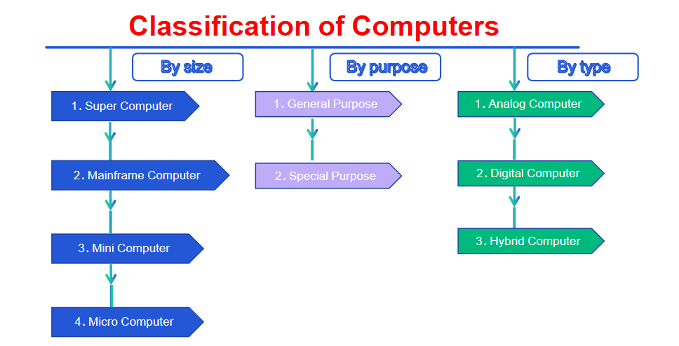

**Super computers -** Deep Blue, Hydra, Jaguar  
**Mainframe computers -** IBM zSeries, Modern mainframes

**Mini computers -** Desktop, Laptop

**Micro computers -** Tablet PC, Pocket calculators

**Servers -** Mail Server, Application Server

**Workstation -** HP Z8 Workstation

**Information Appliances -** Keyboard, Mouse

**Embedded computers -** Central heating systems, GPS systems

1. **A computer system has large RAM, still it requires secondary storage, why? Explain.**

### 1. ****High-Speed Access for Active Tasks****

* RAM is designed for high-speed access, enabling the CPU to quickly retrieve and work with active data. This speed is crucial for efficient task processing, but RAM’s volatile nature means it only stores data temporarily.
* **Secondary storage** is required to store data permanently. Even though RAM provides rapid access for ongoing tasks, it cannot retain any data when the computer is powered off. Secondary storage, on the other hand, ensures that important files, applications, and the operating system are available and intact when the system reboots.

### 2. ****Supports Processing and Execution****

* RAM holds data, code, and instructions that the CPU needs for immediate processing and execution. However, programs and data can only be loaded into RAM if they are stored somewhere long-term.
* **Secondary storage** serves as the main repository from which data and applications are loaded into RAM. Without it, there would be no permanent location to store software, files, or the operating system, making it impossible to run applications or save progress beyond a single session.

### 3. ****Temporary Storage During Operations****

* RAM provides a temporary workspace for active processes. When you open a program, it loads into RAM, where it operates quickly but only for as long as the session lasts.
* **Secondary storage** is needed to save work permanently. Once operations in RAM are completed (e.g., a document is edited), secondary storage allows the system to save the final version of the file. Without secondary storage, all data would disappear once the computer shuts down, as RAM does not provide long-term storage.

### 4. ****Facilitates Multitasking****

* RAM’s speed and ability to handle multiple tasks at once make it ideal for multitasking. However, as more applications are opened, RAM can become full, limiting the system’s multitasking capability.
* **Secondary storage** supports multitasking indirectly by providing **virtual memory**, which extends the system’s available memory by using part of the secondary storage as an overflow for RAM. This allows more applications to be opened simultaneously and enhances the system’s ability to multitask effectively, especially when RAM alone is insufficient.

### 5. ****Supports Operating System Functions****

* The operating system relies on RAM to load essential functions and services needed for system operations. It runs in RAM to ensure speed and responsiveness.
* However, **secondary storage** is crucial because the operating system itself, along with its configuration files, resides in secondary storage. On boot-up, the system loads the operating system from secondary storage into RAM, enabling it to control the computer. Additionally, updates, patches, and logs are stored on secondary storage to maintain a consistent and up-to-date OS.